PROJECT REPORT
ON
“REASONING GAME ”
Submitted in partial fulfillment of the requirement for the award of the degree of

Bachelor of Computer Applications
to
Uttaranchal School of Computing Sciences


SESSION (2025-26)
Submitted To : Submitted By:
Mr. Aagman Kaprwan Aditya Khandwal
Assistant Professor BCA 2 E
USCS UU2509000022

ACKNOWLEDGEMENT

The most awaited moment of any endeavour is successful completion, but nothing can be done successfully if done alone. Success is the outcome of contribution and consistent help of various persons and we thank those ones who helped us in successful completion of this project.
First and foremost, we would like to thanks Prof. (Dr.) Sonal Sharma, Director, USCS for providing a healthy and encouraging environment to study.
We profusely thankful to the “Dr. Sameer Dev Sharma”, Head of Department, USCS and our project Mentor “Mr. Aagman Kaprwan “ been generous enough to provide us an opportunity and accepting our candidature for the most valuable guidance and affordable treatment given to us at every stage to boost our morale.
We express our sincere gratitude to our colleagues with whom we have fruitful discussions which have helped us a lot in giving a final shape to the program.

Aditya Khandwal
Enroll. No UU2509000022
BCA Semester II

DECLARATION

I, Aditya Khandwal . bearing Enrollment No. UU2509000022 ,student of program BCA semester II, hereby declare that the project report entitled Reasoning Game submitted to the USCS, Uttaranchal University, Dehradun, is a record of an original work carried by me under the guidance of Mr. Aagman Kaprwan and this project work has not been submitted to any other University / College for the sake of award of any degree.

Aditya Khandwal
Enroll. No UU2509000022
BCA Semester II
Section-E

CERTIFICATE

This is to certify that Aditya Khandwal, a student of the BCA 2nd Semester at the Uttaranchal School of Computing Sciences, Dehradun, has successfully completed the Project Report on the topic entitled ‘Reasoning Game’ for the academic session 2025-2026.

Under the guidance of:
Mr. Aagman Kaprwan
Assistant Professor-USCS
Uttaranchal University Dehradun

Table of Contents

AKNOWLEDGEMENT…………………………………………………………………………………I
DECLARATION…………………………………………………………………………………………II
CERTIFICATE OF ORIGINALITY…………………………………………………………………..III
1.INTRODUCTION………………………………………………………………………………….…..4
2.OBJECTIVES 5
3.SYSTEM ANALYSIS…………………………………………………………………………………..7
3.1 Identification of Need……….………………………………………………………………………..7
3.2 Preliminary Investigation…………………………………………………………………………….8
3.3 Feasibility Study………………………………………………………………………………………9
3.4 Project Planning and Scheduling……………………………………………………………………9
3.5 Software Requirement Specification(SRS)…………………………………………………….…..10
3.6 External Interface Requirement………………………………………………………………....…11
4.FLOW CHART………………………………………………………………………………………..12
5.DFD Level 0……………………………………………………………………………………………13
6.DFD Level 1……………………………………………………………………………………………14
7.GANT CHART………………………………………………………………………………………..15
8.PERT CHART………………………………………………………………………………………...16
9.CLASS DIAGRAM……...……………………………………………………………………………17
10.SYSTEM DIAGRAM 22
11.FUTURE SCOPE AND FUTURE ENHANCEMENTS…………………………………………...21
12.CODING……………………………………………………………………………………………...24
13.PROFILE OF TWO IT COMPANIES……………………………………………………………..32
14.BIBLIOGRAPHY..………………………………………………………………………………….36

1.INTRODUCTION

The “Reasoning Game” is a simple console-based quiz application developed using C++. The main purpose of this project is to improve the logical reasoning and problem-solving skills of users through a set of 30 multiple-choice questions. The game is designed for beginners and students, making it easy to understand and use.
The questions in the game cover different types of reasoning topics such as numerical sequences (e.g., 1, 2, 4, 8), odd-one-out problems, analogies (e.g., Dog → Bark, Cat → Meow), basic mathematical puzzles, and general knowledge questions. This variety helps users practice different thinking skills in an interesting and engaging way.
The program is implemented using basic C++ concepts. It uses cout for displaying output and cin for taking user input. Conditional statements (if-else) are used to check whether the user’s answer is correct or not, and loops are used to display multiple questions one after another. The game starts with a welcome message and maintains a score counter to track the user’s performance.
After each question, the program provides immediate feedback by telling the user whether the answer is correct or incorrect. At the end of the quiz, the total score out of 30 is displayed along with a performance message such as “Perfect!”, “Good job!”, or “Keep practicing!”. This makes the game more interactive and motivates users to improve.
This project demonstrates basic programming concepts such as variables, input/output operations, loops, and conditional statements. It does not require any external libraries and can run on any system that supports C++, such as Windows or Linux.
In conclusion, the Reasoning Game is a simple and effective educational application that combines learning with fun.

2.OBJECTIVES

The primary objective of the Reasoning Game project is to develop a simple, interactive, and user-friendly quiz application using C++ that helps users improve their logical reasoning and problem-solving abilities. The game is designed to present 30 multiple-choice questions covering various reasoning topics such as number series, analogies, odd-one-out problems, and basic mathematical puzzles. These questions are intended to enhance the user’s thinking skills and encourage logical analysis.

Another important objective of this project is to make learning more engaging and enjoyable. By presenting questions in a quiz format, the game creates an interactive environment where users can actively participate rather than passively learn. The inclusion of different types of questions ensures that users are exposed to a variety of reasoning patterns, which helps in overall cognitive development.

The project also aims to provide instant feedback to the user. After answering each question, the program immediately displays whether the answer is correct or incorrect along with the correct answer. This helps users understand their mistakes and learn from them. The scoring system keeps track of correct answers and displays the final score at the end of the quiz, along with performance-based messages such as “Excellent,” “Good job,” or “Keep practicing.” This motivates users to improve and attempt the quiz again.

A key objective of this project is to demonstrate the use of basic C++ programming concepts. Through this application, important concepts such as:
- Input and output operations using cin and cout
- Conditional statements (if-else) for decision making
- Loops for repeating tasks
- Variables and simple data structures
are implemented in a practical way. This helps students understand how theoretical concepts are applied in real programs.

The overall objective of the Reasoning Game is to create an application that combines education with entertainment. It serves as a learning tool for improving reasoning skills while also acting as a practical demonstration of fundamental programming techniques in C++.

3. SYSTEM ANALYSIS

3.1 Identification of Need
The purpose of this project is to develop a simple and interactive application that helps users improve their logical reasoning skills. In today’s competitive environment, reasoning ability is important for students preparing for exams and interviews. However, many tools available are either complex or require internet access.
The Reasoning Game fulfills the need for a basic, easy-to-use, and offline tool that allows users to practice reasoning questions in a quiz format.
Primary Objective:
To provide users with a platform where they can practice and test their reasoning skills through multiple-choice questions.
Secondary Objective:
To help users evaluate their performance by displaying scores and providing feedback after each question.
Target Audience:
- Students preparing for aptitude tests
- Beginners learning programming
- Anyone interested in brain games and quizzes

3.2 Preliminary Investigation
The developed system is a console-based C++ application with a simple structure and limited scope.
System Scope:
The application runs locally on a computer and does not require internet or external software.
Core Functionality:
- Displays 30 reasoning-based questions
- Accepts user input using keyboard
- Checks answers using conditional statements
- Provides instant feedback (correct/incorrect)
- Calculates and displays final score
Limitations:
- Questions are fixed (hard-coded in program)
- No user account or data storage
- No graphical interface
- Basic error handling

3.3 Feasibility Study
Technical Feasibility:
The project is technically simple and uses basic C++ programming concepts such as loops, conditional statements, and input/output. It does not require any advanced tools or libraries.
Economic Feasibility:
This project is cost-effective as it uses free tools and requires only a C++ compiler.
Operational Feasibility:
The system is easy to use and does not require any technical knowledge. Users can operate it using simple keyboard input.
Schedule Feasibility:
The project can be completed in a short time (1–2 days) as it is small in size and simple in design.
Conclusion:
The project is highly feasible for academic purposes and is suitable for beginners.

3.4 Project Planning and Scheduling
The development of the Reasoning Game can be completed in the following phases:
Phase 1: Planning
- Decide project topic
- Design question set
Phase 2: Design
- Prepare logic for quiz
- Plan input/output structure
Phase 3: Coding
- Write C++ program
- Implement questions and scoring
Phase 4: Testing
- Check program for errors
- Verify output and scoring
Phase 5: Implementation
- Final execution and report preparation

3.5 Software Requirement Specification (SRS)
3.5.1 Functional Requirements
- The system shall display a welcome message
- The system shall present 30 questions one by one
- The system shall display four options for each question
- The system shall accept user input (a/b/c/d)
- The system shall check the answer using if-else
- The system shall display correct/incorrect feedback

3.5.2 Non-Functional Requirements
- Usability: Easy to understand and use
- Performance: Fast response to user input
- Portability: Can run on any system with C++ compiler
- Reliability: Should not crash during execution

3.6 External Interface Requirements
User Interface:
- Command Line Interface (CLI)
- Input through keyboard
- Output on console
Hardware Requirements:
- Basic computer system
Software Requirements:
- C++ Compiler (Turbo C++, Dev C++)

4.Flow Chart:
START
↓
Display Welcome
↓
Initialize Score = 0
↓
Display Question
↓
Take Answer
↓
Is Answer Correct?
↓ ↓
Yes No
↓ ↓
Increase Show Correct
Score Answer
↓
END

5.Level 0 (Context Diagram)

USER
↓
Input (Answers)
↓

REASONING GAME
SYSTEM
↓
Output (Score, Feedback)
↓
USER

6.Level 1

USER
↓
1.Display Question
↓
2. Accept Answer
↓
3.Check Answer

4. Update Score
↓
Show result
↓
USER

7. GANTT CHART

Days → 1 2 3 4 5 6 7 8 9 10 11 12 13 14

Planning ████
Analysis ████
Design ████
Coding ████████
Testing ████
Implementation ████

8. PERT CHART

Start
↓
Planning
↓
Requirement Analysis
↓
System Design
↓
Coding
↓
Testing
↓
Documentation
↓
End

9.CLASS DIAGRAM
USER

-username : string
-password : string

+login() : bool
+signup() : void

GAME
-score : int
-user : string
+playGame() : void

QUESTION
-question : string
-options[4] : string
-correct : char

10. System Design
System Architecture
The Reasoning Game follows a simple procedural architecture implemented in C++. The system is monolithic and runs locally using a command-line interface (CLI).
Primary Components:
1. User Interface
- Uses console input/output
- Displays questions using cout
- Accepts user input using cin
2. Game Logic
- Presents 30 multiple-choice questions
- Checks answers using if-else conditions
- Updates score based on correct answers
- Displays feedback for each question
3. Data Handling
- Questions are stored directly in the program (hard-coded)
- No external file or database is used
The architecture is lightweight and suitable for a single-user offline application.

Data Flow Diagram (DFD)
Level 0 (Context Diagram):
The user interacts with the Reasoning Game system by providing answers. The system processes the input and displays results (score and feedback).

Level 1:
- Question Display Module shows questions
- Input Module takes user answers
- Processing Module checks answers

Modularization Details
The Reasoning Game is divided into simple functional parts using functions in C++:

1. Input/Output Module
Functions:
- Display questions
- Take user input
Responsibility:
Handles interaction between user and program using cin and cout.

2. Game Logic Module
Functions:
- Display questions
- Check answers
- Update score
Responsibility:
Controls the main quiz process and ensures correct execution of the game.

11. FUTURE SCOPE AND FURTHER ENHANCEMENTS

iFuture prospects for the reasoning game can significantly enhance its functionality, usability, scalability, and maintainability. The following areas can be considered for further development:

1. User Experience Enhancements
◆ Graphical User Interface (GUI):
The current system is console-based. It can be upgraded to a GUI-based application using C++ frameworks or tools, making it more interactive and user-friendly.
◆ Rich Feedback System:
Provide detailed feedback after each quiz, such as:
- Time taken per question
- Correct and incorrect answers
- Performance analysis
◆ Multilingual Support:
Add support for multiple languages so that users from different regions can use the application easily.

2. Game Features Expansion
◆ Dynamic Question Bank:
Instead of fixed questions, load questions from external files (like .txt) so new questions can be added easily without changing code.
◆ Multiple Game Modes:
Introduce different modes such as:
- Timed quiz
- Easy, medium, hard levels
- Practice mode
◆ Achievements and Leaderboards:
Track user performance and display rankings to encourage competition and engagement.

3. Data and Persistence Improvements
◆ Database Integration:
Replace simple text files with databases (like MySQL or SQLite) for better data storage and management.
◆ User Profile Management:
Allow users to:
- Update password
- View past scores
- Track progress over time
◆ Secure Data Handling:
Improve security by encrypting user passwords instead of storing them in plain text.
◆ Cloud Storage Integration:
Store user data online so it can be accessed from different devices.

12. Coding
#include <iostream>
#include <fstream>
#include <string>
using namespace std;

// Structure for Question
struct Question {
string question;
string options[4];
char correct;
};

// ================= LOGIN =================
bool login(string &user) {
string id, pass, fileId, filePass;
ifstream file("users.txt");

if (!file) {
cout << "No users found! Please signup first.\n";
return false;
}

cout << "\n--- Login ---\n";
cout << "Enter ID: ";
cin >> id;
cout << "Enter Password: ";
cin >> pass;

while (file >> fileId >> filePass) {
if (id == fileId && pass == filePass) {
user = id;
cout << "Login Successful!\n";
file.close();
return true;
}
}

file.close();
cout << "Invalid ID or Password!\n";
return false;
}

// ================= SIGNUP =================
void signup() {
string id, pass;

ofstream file("users.txt", ios::app);

cout << "\n--- Signup ---\n";
cout << "Enter new ID: ";
cin >> id;
cout << "Enter Password: ";
cin >> pass;

file << id << " " << pass << endl;
file.close();

cout << "Account Created Successfully!\n";
}

// ================= GAME =================
void playGame(string user) {
int score = 0;
char ans;

Question q[5] = {
{"1. 1, 2, 4, 8, ?", {"10", "12", "16", "18"}, 'c'},
{"2. Odd one out?", {"Apple", "Banana", "Mango", "Carrot"}, 'd'},
{"3. CAT=24, DOG=26, BAT=?", {"23", "24", "25", "26"}, 'a'},
{"4. Odd shape?", {"Square", "Triangle", "Circle", "Rectangle"}, 'c'},
{"5. 2, 6, 12, 20, 30, ?", {"40", "42", "45", "50"}, 'b'}
};

cout << "\n===== Welcome " << user << " =====\n";
cout << "===== Reasoning Game =====\n";

for (int i = 0; i < 5; i++) {
cout << "\n" << q[i].question << endl;

cout << "a) " << q[i].options[0] << endl;
cout << "b) " << q[i].options[1] << endl;
cout << "c) " << q[i].options[2] << endl;
cout << "d) " << q[i].options[3] << endl;

cout << "Your answer: ";
cin >> ans;

if (ans == q[i].correct) {
cout << "Correct!\n";
score++;
} else {
cout << "Wrong! Correct answer is option " << q[i].correct << endl;
}
}

cout << "\n===== Result =====\n";
cout << "Score: " << score << "/5\n";

if (score == 5)
cout << "Perfect!\n";
else if (score >= 3)
cout << "Good Job!\n";
else
cout << "Keep Practicing!\n";

// Save score
ofstream sfile("scores.txt", ios::app);
sfile << user << " Score: " << score << endl;
sfile.close();
}

// ================= MAIN =================
int main() {
int choice;
string user;

while (true) {
cout << "\n===== MAIN MENU =====\n";
cout << "1. Login\n";
cout << "2. Signup\n";
cout << "3. Exit\n";
cout << "Enter choice: ";
cin >> choice;

switch (choice) {
case 1:
if (login(user)) {
playGame(user);
}
break;

case 2:
signup();
break;

case 3:
cout << "Thank You!\n";
return 0;

default:
cout << "Invalid Choice! Try again.\n";
}
}
}

Output
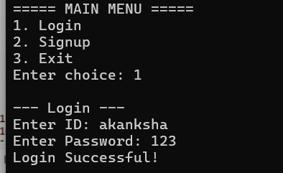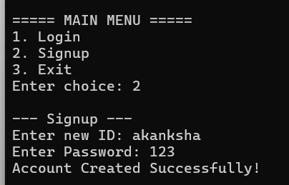
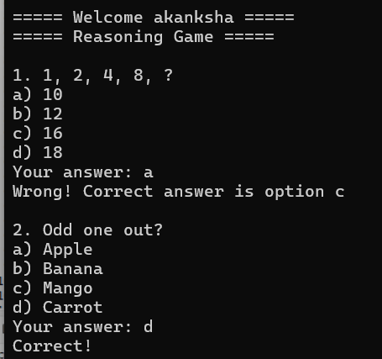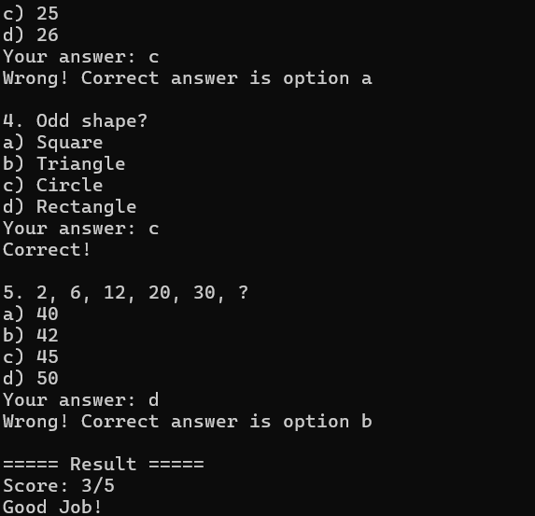

13.Profile of two IT companies:
1. Infosys
(a) Basic Information and Company Overview
Infosys is an Indian multinational company founded in 1981 and headquartered in Bengaluru, India. It is a global leader in IT services and consulting, operating in more than 50 countries and helping businesses with digital transformation.

(b) Services and Solutions
- IT consulting and outsourcing
- Cloud computing services
- Artificial Intelligence (AI) solutions
- Data analytics
- Cybersecurity services
- Digital transformation services

(c) Technologies and Expertise
- Programming: C++, Java, Python
- Cloud platforms (AWS, Azure)
- AI & Machine Learning
- Data analytics and big data
- Web and mobile development

(d) Career and Work Culture
Infosys provides a professional and learning-oriented work environment. It focuses on training freshers and skill development. The company promotes teamwork, innovation, and continuous learning.

(e) Placement Process
Eligibility Criteria:
- BCA/B.Tech/MCA students
- Minimum 60% marks
Procedure:
- Online aptitude test
- Technical interview
- HR interview

(f) Contact Information
- Website: https://www.infosys.com
- Email: info@infosys.com
- Phone: +91-80-2852-0261
- LinkedIn: https://www.linkedin.com/company/infosys

2. Google AI
(a) Basic Information and Company Overview
Google AI is a division of Google focused on Artificial Intelligence research and development. It works on advanced technologies like machine learning, natural language processing, and robotics.

(b) Services and Solutions
- Machine Learning APIs
- Cloud AI services
- Natural Language Processing (NLP)
- Image recognition
- AI model development

(c) Technologies and Expertise
- TensorFlow
- Python
- Deep learning
- Computer vision
- Large Language Models (LLMs)

(d) Career and Work Culture
Google AI offers an innovative and research-driven work culture. Employees work on cutting-edge technologies with global teams. The environment encourages creativity and problem-solving.

(e) Placement Process
Eligibility Criteria:
- Computer science background
- Strong programming skills
Procedure:
- Online coding test
- Technical interview
- System design interview
- HR interview

(f) Contact Information
- Website: https://ai.google
- Email: support@google.com
- Phone: +1-650-253-0000
- LinkedIn: https://www.linkedin.com/company/google

14. Bibliography
- Bjarne Stroustrup, The C++ Programming Language
https://isocpp.org
- E. Balagurusamy, Object Oriented Programming with C++
https://www.mheducation.co.in
- GeeksforGeeks – C++ Programming
https://www.geeksforgeeks.org/c-plus-plus/
- Wikipedia – Data Flow Diagram
https://en.wikipedia.org/wiki/Data-flow_diagram
- Wikipedia – Entity Relationship Model
https://en.wikipedia.org/wiki/Entity%E2%80%93relationship_model

